At first I misunderstood the question and wrote Insertafter in suh a way that if it finds value 1 in the vector it REPLACES the next element with value 2 instead of inserting value 2 after the element. After this was fixed the output was as follows:

I had a problem with the addnode function because I forgot to break the loop which resulted in the addnode just keeps creating new nodes at the end with next pointing to null then to a new node and so on and so forth. I solved this by just breaking the loop when the new node is created and added to the linked listA screenshot of a computer

My print list function worked but looked bad because I forgot to write “the list contains” outside the loop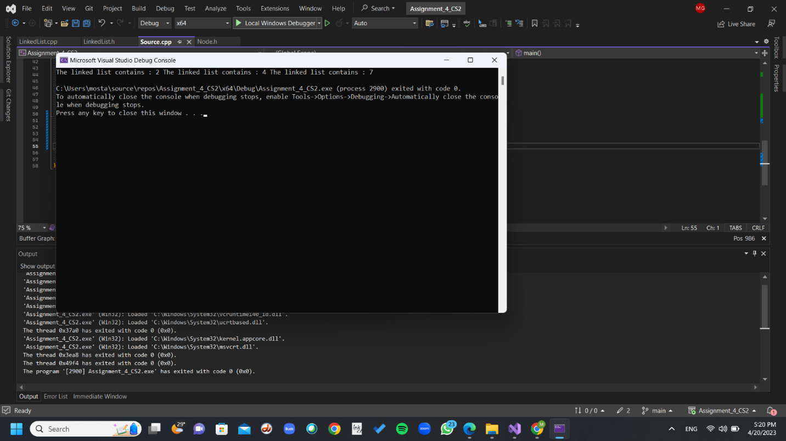

The sum function works as can be seen but I later change the whole list because my implementation here felt like it didn’t need occurrence and since Iam writing occurrence I wanted to use it

I decided to print the occurrence of each element in the print list function but when writing the code I forgot to reset temp so that it equals head which resulted in the loop that prints the occurrences not working at all

After fixing this problem with the print function I encountered another problem with occurrences, they always showed occurrence =1, upon investigating this I was sure the problem is with the addNode function and after sometime of tracing I noticed that I wrote == instead of = at some point which made the mistake happen. After fixing this, occurrences worked A screenshot of a computer

Implementing the vector to linked list function worked as can be seen here :

the compiler told me the error occurred because temp->next is a null ptr which is true because 3 was the last element of the linked list. Therefore, I created an if else condition to deal with removing the last element of the linked list. After fixing this the function worked and everything else worked correctly

